Barriers to Construction, Renovation and Demolition waste management in Ontario

Ramanpreet Sandhu

McMaster University

A thesis for the

partial fulfillment of

Master of Engineering and

Public Policy

*Thesis supervisor*

Dr. Velma Grover

McMaster University

# Abstract

In Canada, 27% of the total solid waste is generated by the CRD (Construction, Renovation & Demolition) industry and is disposed of in a landfill (Yeheyis, 2013). The CRD industry experts suggest that approximately 75% of all the waste generated by the CRD industry has a residual value through recycling and reusing (Yeheyis, 2013). The current recycling rate for the CRD industry in Canada is 16% which is one-fourth of the target set by the Ministry of Environment in Ontario waste diversion goals (OWMA, 2015). According to various researches, the waste is planned into the construction projects even before the project has started. On the other hand, the end of life fate of the waste generated i.e. landfilling or reusing is decided on the basis of costs involved and monetary gains instead of policies being in place (PIC[1], 2015). These problems create a need for better policies, management systems and rating systems. Various barriers which are causing this disparity of proposed targets and actual diversion rates are analysed in this paper in depth. In the end, this paper also proposes some policy recommendations to minimize the waste generated and, incentivize the sustainable practices to deal with the CRD waste. The policy recommendation will be based on the Japanese CRD waste management system because of their 98% CRD waste diversion rate

Contents

Abstract 2

List of acronyms 5

Definitions 5

1 Background 6

2 Introduction 6

3 Problem Statement 7

4 Sources of CRD waste 7

5 Ontario’s status quo 8

6 Japan’s status quo 9

7 Markets in Ontario 13

8 Challenges in Canada 13

8.1 Uncertainty in reporting 14

8.2 Demolition and Deconstruction 14

8.3 Lack of Extended Producer Responsibility 15

8.4 3R’s principle 15

8.5 Markets 16

8.6 Inefficient policy 17

8.7 Waste in perfect shape 18

8.8 Enforcing current policy 19

8.9 Availability of cheap alternatives 20

8.10 Lack of interaction 21

8.11 Management issues 22

9 Solution exists 23

10 Policy Recommendations 25

10.1 Alteration of the thresholds and Building Codes 26

10.2 Pricing for a reform 27

10.3 Extended Producer Responsibility 28

10.4 Mandatory Reporting 29

11 Conclusion 32

12 References 33

# List of acronyms

* CRD- Construction renovation and demolition
* PIC- Personal Interaction with Contractor
* OWMA- Ontario Waste Management Association
* ICI- Industrial, Commercial and Institutional sector
* MOE- Ministry of Environment
* HFH- Habitat for Humanity
* RCO- Recycling Council of Ontario
* WDO- Waste Diversion Organization
* IFO- Industry Funded organization
* D&D- demolition and deconstruction
* EPR- Extended Producer Responsibility

# Definitions

**CRD waste** can be defined as the waste from the construction, renovation and demolition of buildings, bridges, roads etc. in the form of concrete, wood, gypsum, metal etc.

**Waste diversion** in the construction industry can be defined as the ability to collect as many kinds of waste materials from a CRD site, sort them on site by collecting them into different bins and finally shipping them to the transfer stations (PIC, 2015).

# Background

Construction industry is the biggest consumer of the raw minerals extracted from the earth, it accounts for 60% of the raw materials extracted from the lithosphere**[2]**. The building materials account for half to one third of all the manufactured goods[3]. In Canada, the CRD industry accounts for 25% of the waste present in the landfills and for 35% of all the GHG’s emitted in Canada (The Sheltair Group, 2008). The impacts of the CRD industry goes far beyond the project itself as different types of resources are utilized in a single project. The major processes involved in lifecycle of any material are production, transportation, and disposal after the life cycle is completed. So it is very important to have a sustainable approach towards CRD industry when we are dealing with huge quantities of resources.

# Introduction

Ontario has one of the highest per capita productions of solid waste in the world amounting to 1 ton/person/year (2008). It is twice as much as that of Japan and totals to 12 million tonnes and it has been increasing steadily since 1990 (Municipal waste generation, 2013). Each year, almost 80% of the waste is disposed off in landfills, out of which 30% is sent outside the province and the remaining 50% is disposed of in Ontario into the landfills (OWMA, 2015).

The CRD waste generated in Canada is estimated to be about 10 million tonnes, which is roughly 25-33% of the total solid waste generated (Yeheyis, 2013). According to the recycling council of Ontario (2006), the main components of CRD waste are concrete, wood, steel drywall, gypsum, asphalt and other masonry. These components make up more than 60% of residential CRD waste and 80 % industrial, commercial and institutional sector (ICI) CRD waste.

The diversion rate of solid waste in Ontario is 22% which mainly consists of waste from homes and residential sector (39% diversion rate) while the ICI diverts only 12% of solid waste[4]. Therefore, a policy change focusing on these specific materials will be able to get Ontario back on course of the desired 60% goal as per MOE (2004).

There are examples of countries like Japan who have achieved diversion rates of 91% for wood, 98% for concrete and 99% of asphalt waste[5]. They have established various material cycles in their society which reduces their consumption of new resources and increases the reuse and recycling of the already used resources. In this study, I will try to look at their policy framework, existing barriers in Ontario responsible for low recycling rate in Ontario and try to compare the central features of Japanese policies with the existing Canadian policies.

# Problem Statement

This inquiry paper aims to conduct a comprehensive review of the Construction, renovation and demolition (CRD) management regulations in Ontario. Various barriers in the management of the CRD waste are discussed in this paper. The concluding section of paper include recommendations based on the barriers found in Ontario and better CRD waste management practices and policies in Japan. The major question raised in this paper is the reason for less diversion rate of CRD waste in Ontario.

# Sources of CRD waste

The two main sources of CRD waste are residential sector (47%) and ICI sector (53%) (Franklin, 1998). The three components construction, renovation and demolition vary a lot in their contribution to the waste. Renovation is the highest contributor to the residential waste (55%) followed by demolition waste (34%) and the least is construction waste (11%) (Sinclair, 2006). In case of the non-residential sector, demolition is the highest contributor (58%), renovation being the second (36%) and the construction waste is again the least with 6% contribution (Sinclair, 2006). These findings are almost in line with the Recycling Council of Ontario (2006) report that the demolition projects can create 20-30 times the waste created by the new construction projects.

# Ontario’s status quo

In Canada, the power to protect the environment has been divided to all levels of government. The municipal government is responsible for collection, diversion and disposal activities. The provincial government is responsible for licensing, approval and monitoring operations. At provincial level, Ontario regulates the necessary waste management activities at the provincial level for various construction and demolition activities under Ontario’s 3R’s regulation (3R- Reduce, reuse, recycle).

The Ontario Ministry of the Environmental passed its first regulation 102/94, which is applicable on CRD wastes. It focuses on the requirement of waste audits and plans by business owners for waste reduction based on the construction and demolition of the same project[6]. The plan for waste management by owners should include information like: -

* Who is implementing each part of plan?
* When to implement?
* What are the expected results?

The central requirements include measuring the quantity of waste, identifying the composition and the manner in which the waste is produced.

The second and more recent regulation is 103/94 states that owner of buildings with more than 6 residential units are required to separate the waste according to the nature of the source and recycle some types of wastes which are specified in regulation[7]. The mandated items for separation in this regulation are concrete, drywall (unpainted), steel and wood with an exception of drywall in demolition projects. Both these regulations are applicable for the project the buildings with floor area greater than 2000m2.

In the year 2002, the provincial government introduced the Waste Diversion Act to promote the 3R’s principle by setting out rules, regulations and framework for the producer responsibility based diversion program. The Ontario waste diversion goal issued in 2004 by the Ministry of Environment was set at 60% so that the solid waste could be diverted away from the landfills (MOE, 2004).

The rate of waste diversion has been increasing with an overall sluggish trend (Button 2013). However as specified earlier, the 13% diversion rate in Ontario suggests that there are opportunities available for diverting the CRD waste. Most of the municipalities in Ontario plan newer programs for CRD waste in their respective regions for increasing the diversion but they are able to initiate only a handful programs (Button, 2013). These programs have minimal or no effect over the CRD waste stream and some get discontinued due to the monetary constraints.

# Japan’s status quo

In the year 2001, Japan adopted a new framework for promoting the technological and social changes for establishing better material cycle in the society. The law responsible for establishing a material Cycles society defines the recyclable resources and the principles for their utilization.

The government has established various policies for waste management such as waste management such environmental consideration during construction and manufacturing stages. The policies have also focused to develop the independent businesses for the waste management, collection and recycling activities. They are aimed for effective use of resources, reduce waste generation and protect the environment.

The main objective of the law is to create a society in which the consumption of newer resources is retrained and the load on environment is minimized by using the principles of 3R’s and effective waste management strategies. It works by setting targets for three indicators which are:

* Productivity of resource
* Cyclical use rate
* End disposal rate

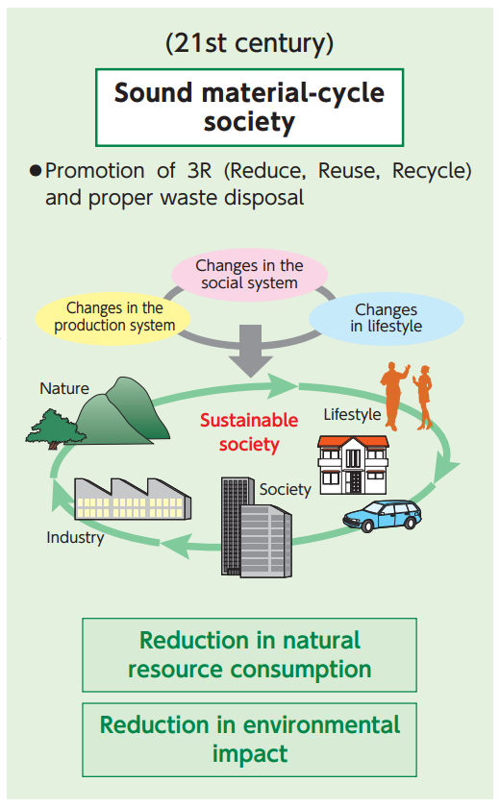

**Source-** <https://www.env.go.jp/en/recycle/smcs/attach/hcswm.pdf>

**Figure 1-** It shows the various themes implemented to attain sustainable development in the Japanese Waste Management.

The legislations dealing with waste management in Japan are:

* Waste disposal and Public cleansing law- The basic purpose of Waste Management law is to limit waste generation and ensure proper storage sorting, collection, recycling, disposal etc. of waste for preservation of living environment[8].
* Law for the promotion of effective utilization of resources- The main purpose for this law is to provide a mechanism for encouraging the generation of new products by utilising the recyclable resources and reusable parts[9].

The law dealing with the CRD waste is known as Construction Waste Recycling Law (2002) which came into effect on May, 2002. It aims to promote the recycling and sorting of waste concrete, asphalt and other materials which get discarded in the process of demolishing of buildings. It requires the contractors to sort out and recycle waste generated at their CRD site. The different types of the designated construction materials like concrete, asphalt, wood are covered under it. Various type of CRD sites are considered according to the area or contracting amount of the particular project in accordance to the minimum threshold specified in the policy.

|  |  |
| --- | --- |
| Type of construction | Standard size |
| Demolition of a building | 80 m2 or more (total floor space) |
| Construction of a new building or extension | 500 m2 or more (total floor space) |
| Renovation work, etc. | Contracting fee (100 million yen or more) |
| Civil engineering work, etc. | Contracting fee (5 million yen or more) |

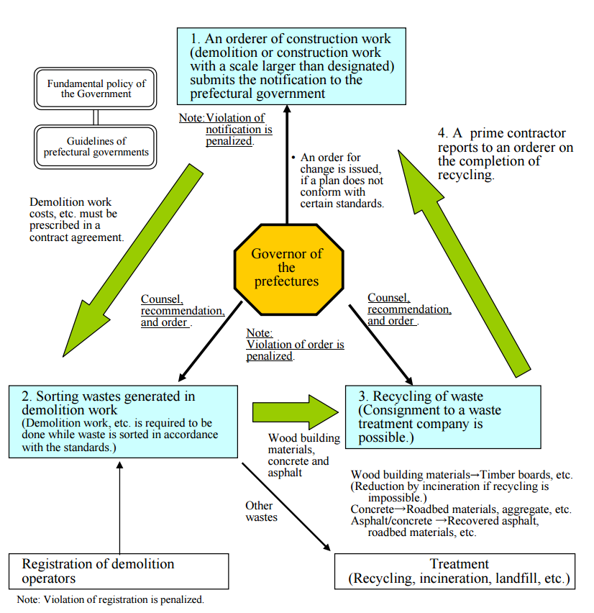

Source: <https://www.env.go.jp/en/laws/recycle/09.pdf>

**Figure 2-**Represents a flowchart depicting the flow of the CRD waste during the recycling activities.

Under this law, the person who is managing the construction works is obliged to submit a plan for sorting the CRD waste to the governor of the prefecture. It has to be done 7 days prior to the start of the work. The projected expense for the demolition and recycling has to be specified in the contract. The contactor is responsible for sending the CRD waste to the treatment. After the completion the contractor reports to the authorities.

# Markets in Ontario

In Ontario, the Habitat for Humanity (HFH) with their network of Restores retail stores is the biggest organization selling the used building materials (Earle, 2013). The organization primarily gets the used materials free from the businesses in the form of donations. The operational costs for processing the used materials are covered by the money which they get from selling their used products at their Restores.

There are also a few private retailers in the province who deal in the CRD waste with the primary focus on wood from sources like CRD waste from barns and businesses which make household furniture (PIC, 2015). However, these retailers are small scale without any infrastructure to handle the large amounts of demolition waste generated in the province. This is where the two CRD waste material yards come into play with their multi-acre facilities (PIC, 2015). These yards receive the waste from ICl sector CRD companies. They sell their products by advertising online and direct contacts with the professionals involved in the construction industry.

A CRD recycling plant with the capacity 400 tonnes/day is currently the only plant of its kind in Ontario. Earle (2013) mentioned that Ontario has the capacity to support 6 such plants.

A major tool which is helping the spread of CRD waste market is internet as it is connecting the waste material companies directly with the CRD industry (PIC, 2105). Some examples of website offering services exclusively in CRD waste are leftover.ca and ontariogreenspec.ca.

# Challenges in Canada

The major problem for the CRD industry in Canada is that the contactors want to get rid of the CRD waste as quickly as possible (Addis, 2007). But in many cases the markets do not exist and the contractors have to pay money to get rid of the waste. The main factors causing low recycling rates in construction industry are:-

## Uncertainty in reporting

The reporting of the amount and type of the construction waste sorted processed is voluntary in nature which means that it depends upon the will of contractors and building owners. In case of voluntary reporting, companies always tend to omit the information in which they come off as bad guys (PIC, 2015). These uncertainties in the reporting of quantity and quality of the CRD waste generated leads to confusion in comparing and understanding the data (Roper, 2006).

At provincial level, the most recent official report by Recycling Council of Ontario on the CRD sector known as *Let’s Climb another Molehill* was presented in the year 2006 (RCO ,2005). This data is 10 years old which is a long time during which the changes in policies and advancement of technology can cause variations in the quantity and composition of the waste being produced. It leads to the lack of data which is vital for providing the clear picture of present scenario, establishing the risk standards, strengthening enforcements, reducing contractual errors and increasing the opportunities for research (Yeheyis, 2013).

## Demolition and Deconstruction

Deconstruction is the process of selective dismantlement in which the important components of buildings are removed for reusing them in another building. The materials recovered in the process of deconstruction can be sold in the used goods market. The factors like time required and labour cost increases during deconstruction (Crawford, 2011). The contractors are unaware of the codes in Ontario for dismantling and deconstruction of old building materials which can be very useful for the extraction of high quality building material for the reusing and recycling (PIC, 2015). Moreover, it is totally a new kind of business which is fundamentally different from the present CRD waste businesses. In this business, companies have to keep materials stored up for some time in search for the right opportunity to sell (Earle, 2013). During this time there is a possibility that stored up material may get obsolete and a new option becomes available which is more durable, cheap and most importantly new. There are other costs involved for hauling, storage and management.

Secondly, present prices of raw material used for construction are such that 30% of the total budget of a construction project is spent on it and the remaining 70% goes to the labour (PIC, 2015). The processes of sorting the waste on site and deconstruction are labour intensive tasks. Therefore, the deciding factor being the money makes contractors more sensitive to the increase of labour cost and they base their decisions on it.

## Lack of Extended Producer Responsibility

In case of the most sustainable construction projects in Canada, the contractor’s responsibility ends once the waste reaches the transfer station. The fate of the CRD waste in a transfer is decided on the basis cost to profit basis. Therefore, some parts of the waste from transfer stations are sent to landfills after considering the cost to benefit ratio of its other uses (PIC, 2015). This is illegal and totally against the 3R’s principle on which the waste diversion policy in Ontario is based.

The Engineering Technology Building (ETB) in McMaster is a LEED silver certified building, where 97% of the CRD waste was recycled after being sorted out at the construction site. It helped them to earn 1 exemplary point. However, the facilities department in McMaster University had no idea on what happened to the waste after it was sent to the transfer station (PIC, 2015). Similarly, many of the construction companies present that their diversion rates are above 90% but they don’t care what happens after the waste reaches the transfer station (Earle, 2013). However, nowadays the contractor has to get a certificate from the transfer station to prove that waste has been disposed properly.

Mostly, the information available to the client looking to recycle the CRD waste is incomplete which leads to uninformed decisions (Crawford, 2011). Therefore, the lack of EPR prevents the CRD waste from going to the used building material retail stores. On the buyer's side, the construction companies and contractors lack the knowledge on the kinds of material which they can buy from a retail store (PIC, 2015). The extended producer responsibility is exactly what is needed here.

## 3R’s principle

The basic 3R principle on which the recycling policies in Ontario focus on recycling with minimum focus on more sustainable options like reusing, prevention and reduction (OWMA, 2015). There is a structured lifecycle hierarchy which considers a complete range of environmental impacts made by a product starting from the extraction of raw material, manufacturing, usage and disposal to determine the best option for lifecycle management. The approach followed by the U.S.E.P.A and European Union follows the complete 3R’s approach. The most preferred option is prevention followed by reduction and then comes the reusing and recycling. The last option is landfilling and incineration. The reusing and recycling occurs after the waste has been generated. The process of reduction can be classified as a precautionary technique to minimize the waste generation from the source side (Yeheyis, 2013).

The construction waste is generally planed into the system by the contractors through over ordering, issues in micro-management, denial of retailer to accept the unused waste etc. The absence of prevention and reduction policies makes the money as the driving factor to decide whether to comply with the best use hierarchy or not (PIC, 2015). The presence of low cost landfilling and for the CRD waste generated completely reverses this hierarchy making bottom option the most preferred.

## Markets

The existence of markets, where contractors could exchange their waste materials with money is critical for sustainable recycling habits. The majority of shoppers at these retail stores are the homeowners who are looking to shop for renovation materials and the small contractors who are undertaking the renovation work (Earle, 2013). The reason behind the consumption only in the renovation sector is that the contractors who are constructing new houses have higher expectations as the latest trends in the interior designing industry is always changing. The ICI sector’s lack of participation is due to the huge variety of components used in it and the quality of the corporate image they have to maintain whereas in general households, the design requirements are more dependent on the taste and budget of homeowner (Earle, 2013). Moreover, the residential projects are smaller in size and larger in number so it is easier for the used material retail stores to match the demand compared to the ICI projects which are huge in size and their requirements cannot be satisfied by a single retail store (PIC, 2015).

Secondly, majority of the areas in Ontario have very few opportunities for managing the waste properly. The recycling and reusing options for the Northern communities are hundreds and sometimes more than a thousand miles away which makes following these sustainable CRD practices very hard (Van de Merwe, 2009). The main reason cited is the amount of money spent on the transportation because hauling the waste for such long distances makes recycling an undesirable option. If the companies try to transfer those transportation costs to their customers then they might be endangered of getting out of business (Angelil, 2010).

However, if companies try to reuse those waste materials near its source of generation or within the same community, more dependable markets would be created easily. The principle of extended producer responsibility can produce fruitful results for the creation of market because then owners have to come up with innovative ideas to deal with the CRD at minimum costs.

## Inefficient policy

The contractors are made responsible for managing the waste by specifying it in the contract (PIC, 2015). In case of demolition projects, the sub-contractor is given the responsibility for clearing the site and dealing with the waste. However, in some cases due to cost concerns, the sub-contractors don’t do sorting and tell the contractor that they will do it later on but finally end up simply shipping the unsorted waste to the landfills (PIC, 2015). These things generally happen because the responsibility of carrying on the diversion is not clearly specified in the regulation and policies related to waste diversion (123/94, 103/94).

Secondly, the producers of waste under the waste diversion act are mandated to combine into a combined stewardship agency also known as Industry Funded Organization (IFO) (OWMA, 2015). The waste diversion organization and industry funded organizations have almost same roles of keeping oversight over the waste diversion practices of the industry. According to the OWMA (2015), both these organizations lack the full range of tools for ensuring that the diversion programs are working according to the plan. The responsibilities and roles of the parties involved in the waste diversion are not well defined in the present framework (MOE, 2009). It leads to overlapping of various duties and responsibilities and make it impossible to hold parties responsible for their acts. This problem of responsibility and authority has been raised in many reports in the past (OWMA, 2105). According to a review paper by Ministry of Environment (2009), presently Waste Diversion Organization and IFO share many same roles and responsibilities for developing the waste diversion programs. Broadly speaking, both WDO and the government have important roles to design various strategies but they lack the set of tools required to check the success of their strategies and programs. The overlapping and complex relationship between the organizations leads to various people working on the same waste diversion activities work harder and the decision making for the public interests becomes tougher.

On the other hand, government is unable to hold the IFO accountable under the current framework. Also stewards under the IFO build a monopoly as buyers of environmental services which result in buyers pooling the demand to lower the price of waste. It eliminates the ability of buyer to reinvest and innovate, thereby disturbing the perfect competition (best option) of market (PIC, 2015). Under this framework, IFO allows the manufacturers to pass the environmental costs to the consumers which leads to minimal innovation and eliminates the business motive to search intelligent ways to lessen the costs.

Therefore, the Ontario government should consider making a more consistent policy framework with clearer and specific roles and responsibilities assigned to the participants. It will facilitate in enforcing the waste diversion policies and penalising the organisations who failed to achieve the diversion targets.

## Waste in perfect shape

The construction materials which get wasted at a construction are in the best condition to be utilised again in another project. The best place for giving them back again are the retail stores from where they are bought in the first place because they can easily sell those materials again.

The ability of the materials to be resold or reuse depends on the nature of product because materials like concrete cannot be returned back as it settles in hours and it is impossible to find a new buyer in such a short period of time. The expensive materials like electrical equipment, metallic pipes etc. can be easily retuned provided they are in proper condition (PIC, 2015).

In these types of used goods, the cost of materials is the deciding factor for reducing the waste. The materials which are in the same condition (unopened and original packing) in which the contractor received them increases the chances of it to be returned back. In some cases, the materials are in proper packaging and proper condition but still cannot be returned back because they were ordered specifically for the project and are not commonly used in the construction industry. This lack of popularity could also act as a barrier and it is directly related to the inability to sell again and indirectly related to cost because the buyers have to sell them at reduced costs or probably have to spend on the storage. Therefore, the fate of leftover materials is dependent on the cost and attitude of seller.

Another most common challenge for the recycling and reusing of the CRD waste is the quality of the waste. The materials which are recovered and have the potential to be reused again are generally contaminated with paints, adhesives and other kinds of toxic wastes (PIC, 2015). It makes the recycling difficult because separating the resource from the toxics needs processing before its final use. This factor is worsened due to the limited time frame.

## Enforcing current policy

The most eminent loophole in the policy causing this problem is the size of the construction projects for which the diversion is mandated. According to the present policy framework of Ontario’s 3R’s regulation, the construction projects having construction area more than 2000m2 must divert 60% of CRD waste. It results in all the construction, renovation and demolition waste from the housing development project and residential renovations going unsorted into the bins. The achievement of overall 60% diversion rate is impossible as residential sector is responsible for 47% of the CRD waste generated in Ontario (Franklin, 1998).

It removes a large portion of CRD waste from the influence of the policy, which makes landfilling the easiest option for disposal. The absence of ban on landfilling and low cost of landfilling attracts a lot of the CRD waste. It is clearly evident from the figure- 2 that residential sector is the better performing sector when compared to the non-residential sector.



Source- OWMA (2015)

**Figure 3-** It shows the variation of CRD waste from residential and non residential sector with time

Another factor influencing the Ontario’s waste diversion framework enforcement by MOE is that it has the capacity of inspecting only 5% of the regulated facilities each year which means once inspected the second inspection will be after 20 years (OWMA, 2015). This much amount of time for an organization is enough to go off track and engage in activities which are against the rules and regulations. The absence of enforcement and oversight is causing inability of the authorities to implement the present regulatory framework. It is also causing difficulty in assessing the extent to which the ICI sectors are separating waste and weather the diversion programs are leading to recycling.

## Availability of cheap alternatives

Many cities in the province have a history of shipping the waste to landfills situated hundreds of miles away from the source of generation and even different countries for disposal or recycling. It is causing an adverse effect on the economy as the province is spending money under the 3R framework to separate the waste components for easier recycling. But the problem is that waste is exported to other countries where it is utilized as a resource. They get the “waste” in very cheap prices from Ontario because of the absence of markets and recycling infrastructure in Ontario (OWMA, 2015). It results in a large portion of Ontario’s money paid in the form of taxes utilized to sort the waste actually subsidising the recycling activities of the foreign companies. Therefore, a sustainable market is needed to support the products which are made whole or in part by the recycled products. A supportive business environment can help to foster sustainable waste management companies to create a market and recycling infrastructure.

On the other hand, the waste concrete from a CRD site is recycled and used for the non structural purposes. These practices are sustainable but they do not recognize the complete potential of the waste produced. In Japan, there are provisions for adding 20% RCA to normal aggregates and; it will produce a minimal effect according to the (Design code in China GB50010). According to (Kwan, 2012), with 30% of replacement of Normal aggregates with RCA, the decline in strength of concrete was just 10% (observed in the figure- 5). The 56-day strength is 41Mpa compared to 46Mpa). There is a slight decrement, which will have no significant effect in the whole structure. So if we use recycled concrete in the low and medium rise buildings, this decrease in strength will be neglected because of lesser amounts of structural loads.

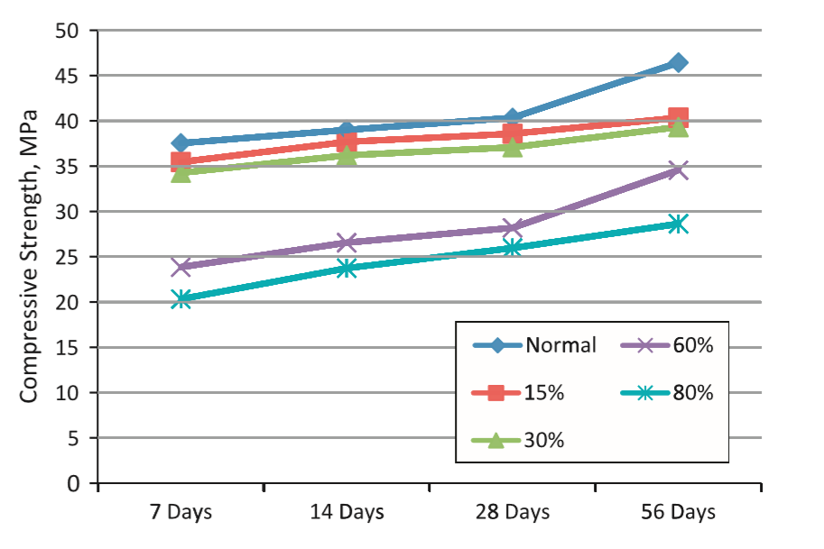

**Figure 4-**It shows the variation in the amount of variation in strength with the relative proportion of RCA in it (Kwan 2012).

## Lack of interaction

The homeowners willing to use the salvaged materials in their construction project have very little or no knowledge about the availability of such recyclable materials at cheaper costs. This is due to scarcity of connections between the CRD waste retail store owners and the users. This leads to retailers storing the used materials in their shops in the wait of buyers. Earle (2013) described that due to limited storage, some retail stores have to implement “dumpster therapy” in which they have to sell all the stored slow moving materials at minimal costs just to free up the space for materials which are higher in demand.

The contractors never bring this up to the notice of their clients because the clients presume that refurbishing used materials will require extra time to make them suitable for reuse. A “middle man” or a market place which can be in the form of retail stores, advertisement organization or just a website like Kijiji.com and Craigslist.com will be helpful in bringing the two parties together.

## Management issues

There are many agreements signed between owner, contractor, design-builder, construction manager, contractor, subcontractor, architect and consultant before the start of a building project. A contract is written specifically to communicate the ideas of the owner to the contractor (Jergeas, 1996).

These agreements include several clauses which influence any rework or waste occurring during construction. These clauses are mainly categorized into categories like testing, geotechnical report, shop drawing, workmanship, quality, substitution and field quality control (Mendis, 2013).

The presence of many categories in contracts and many stakeholders sometimes leads to different interests which lead to conflicts. The factors leading to disputes are ambiguous communication and unclear working procedure. The clients and contractors are generally in hurry and always demand to decrease the time of the pre-construction phase, which leads pre-mature production of contract (Love 2002). The fast track projects are more prone to errors and omissions in the document production due to the shortage of time (Love, 2002). The CRD waste management is a multi- disciplinary effort, which requires different disciplines working in coordination perfectly with each other. The poor coordination between the various actors involved is the another cause for waste generation (Love, 2003).

# Solution exists

Some simple innovative steps like sorting the waste into different containers at a job site, selecting the right recycling plant with higher recycling efficiency, reporting the amount of waste generated can differentiate a project or a company from others.

There are many existing solutions which the CRD industry can apply to reduce the waste ending up in the landfills. In Canada, the policies governing the waste management focus on the 3R’s principle but recycling is the most often employed solution. However, the most preferred option in the waste management hierarchy is prevention followed by minimization than reuse and then comes recycling. An example of reuse can be adaptive reuse i.e. employing the whole building to a different use in which it can serve the new function. The reusing alternatives to demolition are deconstruction (partial or full), employing the older buildings to adaptive uses, designing new building to facilitate deconstruction. These methods facilitate the recovery of material from old building which can be easily employed in the construction of newer buildings. For such practices to be adopted widely there is a need for a stable market of the recovered materials. Deconstruction is an example of recycling in which the building is dismantled entirely or partly and this process yields materials which are valuable and can be used in the new buildings (Densley, 2011). There are codes available in Canada like Deconstruction of Buildings and their Related Parts (2012) and Guideline for Design for Disassembly and Adaptability of Buildings (2006) which assist in improving the deconstruction and designing practices of the CRD projects. If the construction industry follows these codes then the market of recycled products will get a great push forward because of the availability of good quality recyclable products (Addis, 2007).

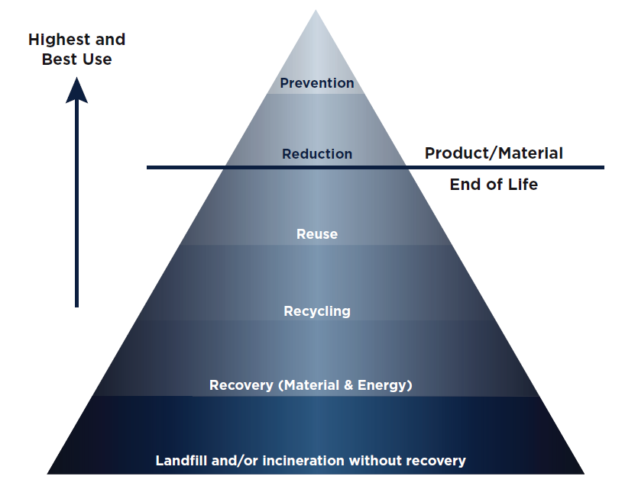

Source: OWMA, (2015)

**Figure 5-** It shows the preferred waste management hierarchy

In case of new construction, choosing those materials which can be easily recycled and designing in such a way that deconstruction is easy will decrease the future impacts of buildings to a great extent (Calkins, 2009). Moreover, in newer construction, contactors include an extra amount while ordering to compensate for any error which could result in delay in the later stages of construction. However, these materials if not used get wasted and end up in the waste stream. But there are some suppliers who take back the leftovers after the job is complete and pay discounted prices back to the contractors (Winkler, 2010). Therefore, working with such suppliers can be beneficial for the contractors and environment both. Despite of the existence of opportunities a lot of CRD waste is ending up in landfills and the diversion rate is only 16% (Button 2014). So a public policy change is required to successfully harness the intrinsic value of waste.

# Policy Recommendations

The recommendations are primarily targeted towards the provincial government as they are responsible for promoting waste diversion, issuing approvals and making and enforcement of standards. The ***foremost recommendation is to alter the basic 3R’s principle*** governing the waste diversion policies in Ontario. The 3R’s policy recommends the reusing, reduce, and recycling with same weightage given to each. This eliminates the best and highest cost effective solutions which include prevention and reduction. This approach can be implemented by using the “cradle to cradle” principle.

The pattern of life of a product is linear in nature which means that there is a starting point and an endpoint like ‘cradle to grave’ model. In this model, the major steps involved in the life of a project are production, consumption and disposal. In the final stage, material like concrete, wood, masonry and other materials with the potential to be reused or recycled gets wasted.

In this approach, there is an increased emphasis on recapturing the used resources and returning them to the economy in the same or different forms. There are many organizations which are spending millions of dollar for the development of circular waste pattern but still there is a discrepancy between the effort by the big industries compared to the efforts by the medium scale and small scale industries and the government’s regulatory framework.

The policies based on ‘cradle to cradle’ model and ideas like zero waste sound very interesting to normal ears but for contractors, these are ineffective until the cost of landfilling is low and enforcements are not there. It will be beneficial for the economy as 2009 report by Ontario government stated that 7 jobs will be created for every 1000 tonnes of CRD waste generated in a circular economy model (OWMA, 2015).

Secondly**, *the CRD waste market Ontario lacks competition and accountability****,* which are very vital for the diversion of waste. On the other hand, countries like UK, Sweden and Australia analyse their policies in terms of their impact on the competition present in the market (OWMA, 2015). The principle followed is that the policies should not restrict competitiveness and if it does than the benefits should outweigh the costs.

## Alteration of the thresholds and Building Codes

***The minimum area thresholds have to be decreased for the CRD projects to be covered under policy from 2000m2 to 80m2 in case of demolition and 500m2 for a new construction project.*** These thresholds have been taken from the policy in Japan because they have served their purpose very effectively in Japan by fetching them a diversion rate of 98% in this sector.

The increased diversion opportunities will force the residential sector to divert their waste towards the transfer station. The transfer stations would have the opportunity to transfer them to the restores which will increase the availability of materials at retail stores which are in demand in the residential sector and simultaneously increase the recycling rate. The demand of used materials at restores by the residential sector is already high which will eventually help to create a self-sustaining market.

Secondly, the building code in Canada is upgraded every five years. The research in waste management and policy measures get upgraded at much higher frequency. The timeline of making any amendments to the building code is very long. A minimum of 2 years is needed to introduce any new thing into the code. There is different patchwork of diverse building requirements in different communities which make it challenging for the construction sector to manage the alterations.

These complications can be resolved by making a ***new Building Act which will establish more consistent building code amendment requirements throughout the province and streamlining the building code making process***. In this the local governments have to give up their by-law which go beyond the provincial building codes. The main theme should be to increase the flexibility with the present day needs for CRD waste management. It will enhance the province’s ability to review the innovative ideas and turn them into standards. The present system works on extensive consultation with the industry and stakeholder. Therefore, 2-4 years of phase-out period is required to allow local governments to adapt to the new provisions.

## Pricing for a reform

An increase in the price of materials will help to counter-balance the ratio of money spent on labor and eventually influence the waste management and disposal decisions made by the contractors. The ***price of raw materials can be increased by putting the levy on them***. It will be used to incentivize the end of life management and disposal costs.

According to the rule of thumb in civil engineering, the average life of a building is 40-50 years. It makes implementing the principle of extended producer responsibility in conventional ways really hard because things change a lot in the span of 50 years. Therefore, the solution to this problem includes increasing the prices of raw materials which will be paid by the producers at the time of construction.

The money received will be used for the end of life management of building by incentivizing the demolition and deconstruction (D&D) practices. This monetary incentive will also help to balance the extra costs involved in the sustainable practices to be followed during D&D. This will help to increase the extended producer responsibility because instead of dumping in landfills, the contractor is inspired to keep the used material in good shape because it will help him to fetch good prices for his product. The contractor will get motivated to sell their used material at good prices.

The increase in the cost of raw material will also help to decrease the amount of waste produced during the construction practices because presently labor cost is the deciding factor. Therefore, leading companies do over-ordering to prevent the waste of time due to the unavailability of materials. The increased prices will also incentivize the returning of waste at a construction site because it is now worth more and contractors will also try to deal with the retailer who makes returning the waste easier. It can be enhanced by certifying the materials so that these materials can meet the required standard and helps to create a positive image in front the buyers and retailers (Eijk & Brouwers, 2009).

Overall, a sustainable market will be formed from the increased prices as it is incentivizing both buyers and sellers. It will be self–sustaining in nature because the new equilibrium of labor costs and material costs will be effectively supporting it.

There are many example where pricing the materials has led to environmentally sustainable practices like pricing the plastic bags in Ontario. After 2009, the shopping stores started charging 5 cents for plastic bags which were complimentary with the goods purchased at a shop previously. According to one of the leading stores Metro, it led to a drop of 70%-80% in their use of plastic bags[10]. Another example is the End of Life Vehicle recycling law in Japan in which consumer has to pay a fee at the time of purchase of the car (Kandlikar, 2007). It helps them to cover the recycling costs for the car at its end of life stage. The increased prices at the time of construction makes it easier for the owners to pay because no one wants to pay for something which is of no use to them.

## Extended Producer Responsibility

Presently, the role of demolition contractors ends after transferring the waste to the transfer station.However, for the successful implementation of EPR, ***the contractor’s responsibility should extend to a point where the waste is being recycled.*** The EPR can be implemented by the municipal government. The framework which was used in Japan can be applied in Canada too.

Once the authorities agree on the recommended plans and releases the authoritative orders, the commissioned party starts the work of demolition or deconstruction followed by sorting. The commissioned party will be responsible for carrying out the registration and transportation during the waste recycling process, which will eliminate the role of the transfer stations. After the recycling is complete the contractor has to notify the municipal authorities again that the waste has been recycled. Then, they may have the option of either recycling in their own project or selling it to a CRD used material retail stores or Restores.

The disputes arising from errors contract can be solved by making the CRD waste producers fully responsible for the fate of waste under the extended producer responsibility principle.

The extended producer responsibility will give a push to the business for deconstruction because it will be the responsibility of the owner to take care of buildings. The extension of responsibility will force them to extract the useful materials from old buildings. It will also help in closing the loop on the CRD waste. This kind of policy will increase the availability of used materials in the market thereby giving it a boost towards self-sustainability.

## Mandatory Reporting

The mandatory reporting will make reporting an obligatory activity in the whole reporting process. It will increase the transparency of the various environmental impacts and will expose the opportunities as well as risks. The investors, NGO’s, current and potential employees, and competitor’s comparison are interested in these reports to determine the future of the company using sustainability as the decisive criteria. Waste management is big part of a company’s sustainability plan. The framework of Global Repotting Initiative can be used as baseline because of it’s adaptable and flexible. It is an international standard which is acceptable throughout different industries and sectors through out the world. The main contents of the report will be the weight of the hazardous and non hazardous waste disposed by using following methods[11]: -

* Reuse
* Recycling
* Composting
* Recovery, including energy recovery
* Incineration
* Deep well injection
* Landfill
* On-site storage
* Other (to be specified by the organization)

Other contents of the report include further details about disposal like: -

* Disposed by the organization undertaking CRD or otherwise stated
* Information provided by the waste disposal facilities about the final disposal methods

The contractor will be required to notify the municipalities about the quantity and type of waste produced and should include the above mentioned details.

Konar (1995) studied the effect of mandatory reporting on the emissions and concluded that overall effect is positive i.e. 32 out of 40 firms were emitting lesser pollutants than before. The emission reduction impact on firms who were already viewed as dirty was less than the firms who were viewed as cleaner earlier. The mandatory reporting will be able to expose them and hit those firms harder which were not known to be dirty by the public earlier.

The studies have shown that information disclosure is not very effective by itself as it needs to be paired with strong administrative punishments like fines (Huang, 2014). The quality of information provided under mandatory framework is improved because the repetition of the previous year’s information is reduced to a great extent (Nelson, 2014)

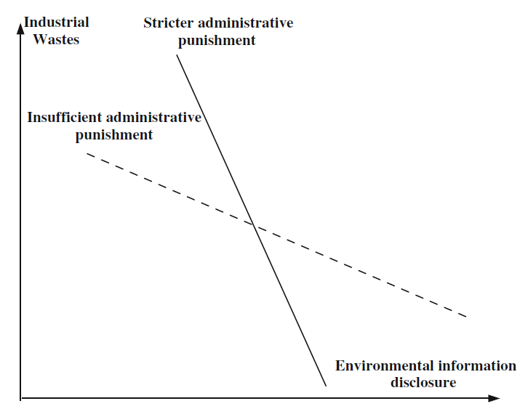

**Figure 6-** It shows the difference between environment disclosure with or without strict administrative punishment

Some companies tend to avoid the information disclosure because the monetary fines in the administrative punishments cost them less compared to the costs which they have to incur in disclosing the information and the consequences of that information in the market (Huang, 2014). These types of firms react to punishments like sentencing the managers. Therefore, mandatory reporting should be established accompanied with strict administrative punishments.

The mandatory reporting is known for effectively promoting the socially responsible management practices. The example of a country where reporting is mandatory is USA and where reporting is voluntary is Germany. The comparison of both the countries in terms of the environmental reports released revealed that the reports released by companies in USA are bigger in size than the German companies (Saida, 2009).

The mandatory reporting will help to strengthen the enforcements because contractors will be providing the true reports of the waste produced themselves and government would have to worry only for those contractors who fall short according to the policy. It will also enhance the contractor’s knowledge of policy and his responsibilities because after providing the true data to the government, he has to take care of the waste produced according to the policy as it has been disclosed. Therefore, it will help to reduce the contractual errors by improving the quality of information available to the contractors. It will also curb the problem of shortage of research on the topic of CRD waste because the absence of data will be no longer a problem.

The enforcement of this policy can be carried out by the non-profit private organizations which can work at an arm’s length with the government. Such administrative authorities help to reduce the costs paid by the government and improve the outcomes of the regulatory framework because they have the ability to invest in more focused expertise and recover the cost directly from regulated community. The public sector is generally thought to be better at making new policies than implementing them and, the government is dealing with thousands of certificates for approvals which are out-dated. Therefor this strategy will give those facilities the room to disregard the present environmental standards (Peters, 2010).

It will aid to develop a long term strategy based on facts and sound data which will be critical for the successful implementation of instruments like EPR, disposal bans, and landfill taxes.

# Conclusion

According to Rene Gratton, from the Canadian Resource Initiative, the Canadian construction markets are very immature compared to the Japanese and European markets. The multinational companies with experience in more stringent policy environment due to hard diversion rules will lead to increased competition in the Canadian market. She added, “If Canadian construction companies think LEED is complicated, they have no idea. Corporate Social Responsibility requirements and carbon footprint regulations and policies are going to come into place and they are going to have to record all that because it will be mandated”.

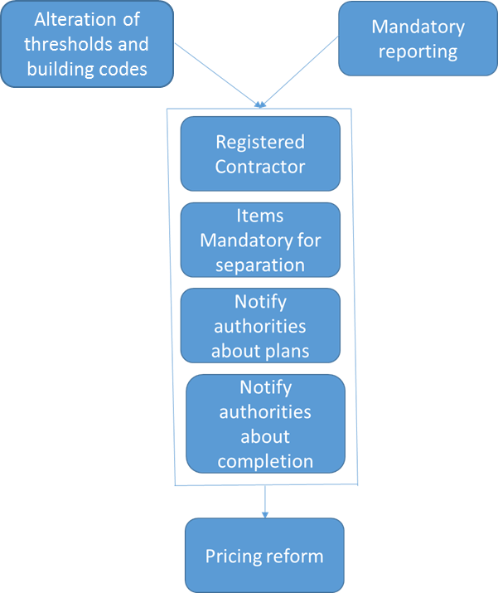

**Figure 7-** It shows the differ policy option implication flow with time

In order to shift the economy of Ontario toward a more circular economy, it is of great importance to implement a framework which drives the best use and highest benefit to cost ratio. The implementation of mandatory reporting and alteration of minimum thresholds and building codes should be implemented now. The policy of EPR can be implemented after doing extensive research for its implementation from the data gathered by the mandatory reporting. The pricing reform is a long term policy which might need a phase out period.

# References

Recycling Council of Ontario (RCO) (2005), let’s climb another molehill.

Abbas A, Fathifazl G, Isgor OB, Razaqpur AG, Fournier B, Foo S, (2006); Environmental benefits of green concrete.

Button Avneet, Lee Wonjong, Marshall David, Dawood Zoha ,MacLellan Shawn, Honorio Umali, Sheree Pagsuyoin (2014), Management of Construction and Demolition Waste in the Region of Waterloo

Bossink, B. A. G.; Brouwers, H. J. H. (1996); Construction waste: quantification and source evaluation, Journal of Construction Engineering and Management

CBC News (2103); Canadian population surpasses 35 million. Available online at: <http://www.cbc.ca/news/canadian-population-surpasses-35-million-1.1869011>

Daily commercial news (2014), Ontario struggles to divert construction waste. Available online at: <http://dailycommercialnews.com/Associations/News/2014/11/Ontario-struggles-to-divert-construction-waste-1004217W/>

Dammak Saida (2009); Contribution on the analysis of the environmental disclosure: a comparative study of American and European multinationals.

David R. Boyd, Canada vs. the OECD: An Environment Comparison, 2001 (accessed August 19, 2008)

Friedman M. (1999); Consumer boycotts: effecting change through the marketplace and the media.

Garrod, N. (2000); Environmental contingencies and sustainable modes of corporate governance.

Huang Rongbing, Chen Danping (2014), Does Environmental Information Disclosure Benefit Waste Discharge Reduction? Evidence from China

Jergeas, G., Hartman, F. T. (1996). A contract clause for allocating risks, in Proceedings of the 40th Annual Meeting of Transactions of the American Association of Cost Engineers

Love, P. E. D. (2002); Influence of project type and procurement method on rework Costs in Building Construction Projects,

Muluken Yeheyis (2012); An Overview Of Construction And Demolition Waste Management In Canada: A Lifecycle Analysis Approach To Sustainability

Municipal Waste Generation (2013); Available at:- <http://www.conferenceboard.ca/hcp/details/environment/municipalwastegeneration.aspx#ftnref6>

Nelson Karen K, Pritchard Adam C (2014); Carrot or Stick? The Shift from Voluntary to Mandatory Disclosure of Risk Factors

Nwzad Abduljabar Abdulla (2007), Effect of Saline Environment on the Strength of Reinforced Concrete Beams

Ontario Ministry of environment (2009); From Waste to Worth: The Role of Waste Diversion in the Green Economy Minister’s Report on the Waste Diversion Act 2002 Review

Poon, C. (2007), Reducing construction waste.

Peters B. Guy (2010), Bureaucracy and Democracy

Seung-Tae , Ramnath Narayan Swamy, Seong-Soo Kim, and Yong-Gul Park (2008), Durability of Mortars Made with Recycled Fine Aggregates exposed to Sulfate solutions

Sinclair, R. Natural Resources Canada, (2006). An Analysis of Resource Recovery Opportunities in Canada and the Projection of Greenhouse Gas Emission Implications.

Slater E, Alam MS (2011) Sustainable green concrete made with FRP scrap and recycled concrete aggregate

Ilozor, B.D. (2009). Differential management of waste by construction sectors: a case study in Michigan, USA

Statistics Canada (2010), Waste Management Industry Survey: Business and Government Sectors

OWMA (2015), Rethink waste 2015: Evolution towards a circular economy

Franklin associates (1998), Characterization of building related construction and demolition debris in united States

Earle, (2007), Identifying Barriers to Reducing Ontario’s Construction Waste Through Reclamation, Reuse, and Recycling

Densley Tingley, D. & Davison, J. B.(2011), Design for deconstruction and material reuse

MOE (2004), Ontario’s 60% Waste Diversion Goal- A Discussion Paper

Kandlikar M. (2007), Assessing extended producer responsibility laws in Japan

CNBCnews (2010), And they said it wouldn't catch. Available at- http://www.cbc.ca/news/canada/and-they-said-it-wouldn-t-catch-on-1.901224

1. PIC- Personal interaction with contractor
2. Raw material consumption, global trends and U S share." UNEP/GRID-Arendal Maps and Graphics Library. 2004. UNEP/GRID-Arendal. 31 Dec 2007
3. World Business Council for Sustainable Development, The sustainability initiative
4. Ontario Ministry of Environment (2009)
5. http://viaexpo.com/en/press/recycling-waste-packages-in-japan-construction-waste-recovery-mariusz-grabda
6. https://www.google.ca/url?sa=t&rct=j&q=&esrc=s&source=web&cd=1&cad=rja&uact=8&ved=0CB4QFjAA&url=http%3A%2F%2Fwww.wastecogroup.com%2Fdocs%2F1.%2520ON%2520Reg.%2520102%2520-%2520Waste%2520Audits%2520and%2520Waste%2520Reduction%2520Work%2520Plans%2520Official%2520Legislation.pdf&ei=Kg-MVaevH4iXgwSexYPoDA&usg=AFQjCNEmkQ0LJ8oKqraBUrwsXH36ms2o3w&sig2=rjUZP-HkfC250Y_6XcN2ig&bvm=bv.96782255,d.eXY
7. http://www.ontario.ca/laws/regulation/940103
8. http://nett21.gec.jp/Ecotowns/data/et_c-04.html
9. http://www.meti.go.jp/english/information/data/cReEffectLe.pdf
10. http://www.cbc.ca/news/canada/and-they-said-it-wouldn-t-catch-on-1.901224
11. https://g4.globalreporting.org/specific-standard-disclosures/environmental/effluents-and-waste/Pages/G4-EN23.aspx