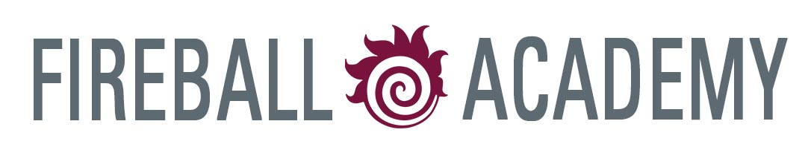

McMaster Industry Liaison Office (MILO)

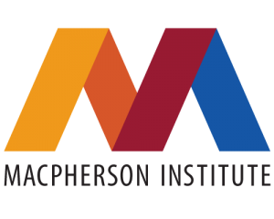
Faculty of Engineering’s New Faculty Orientation
July 7 – 31, 2025

Monday, July 7, 2025

1:30 – 3:00pm Outreach & Engagement
MS Teams Lindsay Bolan, Director, Outreach & Engagement
Communication & Branding
Keiko Kataoka, Manager, Communications
Michelle Donovan, Associate Director, Reputation Development
Wade Hemsworth, Public Relations Manager

Tuesday, July 8, 2025

1:00 – 3:00pm Graduate Attributes 101
JHE 328/A Sarah Dickson-Anderson, Associate Dean, Undergraduate Studies
and via Zoom Shelir Ebrahimi, Associate Chair, Undergraduate Studies, Department of Chemical Engineering

Friday, July 11, 2025

1:00 – 3:30pm Research, Scholarship, Innovation & Industry
JHE A114 Carlos Filipe, Associate Dean, Research, Innovation & Partnerships
Gregor Lawson, Director, Research, Innovation & Partnerships
Ross Huyskamp, Research Contracts Advisor (Science and Engineering), McMaster Industry Liaison Office (MILO)
Miky Dumitrescu, Senior Advisor, Development, Research Office for Administration, Development & Support (ROADS)
Emmanuel Richard, Research Security Officer, Office of the VP, Research
Ammar Taimuri, Research Security Officer, Office of the VP, Research
Nana Ofori-Opoku, Assistant Professor, Department of Materials Science and Engineering

Thursday, July 17, 2025

1:00 – 2:00pm Academic Integrity
MS Teams Kimberly Mason, Academic Integrity Officer

Tuesday, July 22, 2024

1:00 – 3:00pm Structuring a Successful NSERC Discovery Grant
JHE H324 Carlos Filipe, Professor and Associate Dean, Research, Innovation &
Partnerships
Gregor Lawson, Director, Research, Innovation & Partnerships
Michael Noseworthy, Professor, Electrical and Computer Engineering

Thursday, July 24, 2025

9:00am – 12:00pm Mentorship
JHE 328/A Greg Wohl, Chair, Department of Mechanical Engineering
Kathryn Grandfield, Associate Dean, Graduate Studies

Tuesday, July 29, 2025

11:00am – 12:00pm Developing an Effective Teaching Portfolio
JHE 265 Chris Lombardo, Educational Developer, MacPherson Institute

Please refer to SPS B2 – Teaching Portfolios and this Teaching Portfolio Guidebook to begin preparing your teaching portfolio in advance of this consultation/feedback session

12:00 – 2:00pm Lunch with Dean Sheardown
The Phoenix Bar & Grill

Thursday, July 31, 2025

3:00 – 4:00pm Developing an Effective Teaching Portfolio
MS Teams Chris Lombardo, Educational Developer, MacPherson Institute

Please refer to SPS B2 – Teaching Portfolios and this Teaching Portfolio Guidebook to begin preparing your teaching portfolio in advance of this consultation/feedback session

Instructional Skills Workshop
July 14, 16 & 18, 2025

The Faculty of Engineering’s Fireball Academy has partnered with The Paul R. MacPherson Institute for Leadership, Innovation and Excellence in Teaching to offer the Instructional Skills Workshop (ISW) in small group settings within the Faculty of Engineering. This engaging, evidence-based workshop is designed to enhance the teaching effectiveness of both new and experienced educators.

The ISW presents a framework for planning and delivering lessons and provides a forum for participants to deliver three participatory lessons to a small group of peers and reflect on a variety of feedback. Participants will each design and deliver three 10-minute, participatory mini-lessons and provide constructive feedback on the lessons of others. Many experienced instructors use this workshop as a place for refining their ideas about education and trying out new approaches for their classes.

By completing this workshop, instructor participants will be able to:

- Construct intended learning outcomes (ILOs)
- Incorporate active learning strategies into lessons
- Enhance lesson planning and delivery approaches
- Collect and utilize feedback from learners about lesson delivery
- Provide valuable and constructive feedback on others’ lessons

In fulfilling the time and participation requirements of the ISW, you will earn an internationally recognized Instructional Skills Workshop certificate. The workshop will be held in an in-person format on the following dates. Space is limited for this Engineering-specific offering. Please click here to register early to guarantee your spot. The deadline to register is Friday, May 30, 2025. Those interested in registering will need to be able to commit to all the dates indicated on the schedule below to successfully complete the ISW and receive a certificate.
Monday, July 14 8:30am – 4:30pm JHE A114
Wednesday, July 16 8:30am – 4:30pm JHE A114
Friday, July 18 8:30am – 4:30pm JHE A114

Please contact Andrea Colbert-DeGeit, Manager, Faculty Relations at (colbert@mcmaster.ca) or Chris Lombardo, Educational Developer (lombarcl@mcmaster.ca) with the MacPherson Institute with any questions.

